Chapter 2 Programming Exercises

1. Declare and assign a variable, course, the value of 102. Display the variable identifier with its value to the screen.
2. Declare and assign a variable, num, the value of 6.33. Display the variable identifier with its value to the screen.
3. Declare and assign a constant, GR, the value of 1.618. Display the variable identifier with its value to the screen.
4. Declare and assign a variable, dataIn, which can read input from the user.
5. On the previous step, what Java statement do you have to have prior to the program’s beginning? Make the answer display to the screen.
6. Ask the user for a number. Ask the user for another number. Add these two numbers together and display to the screen both of the numbers and the sum.
7. Declare and assign a variable, side, the value of 17.
8. Declare a variable, number, and assign it a value of 10, display it to the screen. Reassign the number variable to the value of 100 and display the change to the screen, tell the user what happened.
9. Take the variable, number, *cast* it to a double and divide it by 3, display the result to the screen (the decimal portion of the answer has to be showing), tell the user what happened.
10. Write a Java statement for the equation: P = 4 x side. Tell the user what is happening and display the answer to the screen.
11. Write a Java statement for the equation: A = side2. Tell the user what is happening and display the answer to the screen.
12. Write a Java statement for the equation: SA = 6 x side2. Tell the user what is happening and display the answer to the screen.
13. Declare a variable, base, the value of 2.
14. Declare a variable, height, the value of 5.
15. Write a Java statement for the equation: V = base x height / 3. Tell the user what is happening and display the answer to the screen. *Hint: you will have to modify (cast) one of those variables to get the correct answer.*
16. Declare a variable, number, the value of 5.
17. Write a Java statement that will tell me what the **remainder** is when number is divided by 2.
18. Translate the following equation into a Java statement and display the result, tell the user what happened:

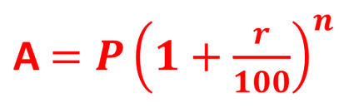

1. Declare a constant that holds the value of 0.3048. Ask the user for how many feet they would like to convert to meters, perform the calculation and display the result.

m = ft * 0.3048

1. Declare a constant that holds the value of 3.2808. Ask the user for how many meters they would like to convert to feet, perform the calculation and display the result.

ft = m * 3.2808

1. Declare a constant that holds the value of 0.9144. Ask the user for how many yards they would like to convert to meters, perform the calculation and display the result.

m = yards * 0.9144

1. Declare a constant that holds the value of 32. Ask the user for the temperature in Fahrenheit, perform the calculation that will convert this temperature to Celsius and display the result (remember how int division works! Make sure your answer is correct!).

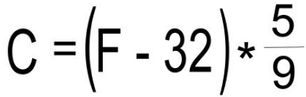

1. Convert inches to feet. Ask the user for inches and convert to feet, make sure to show the left over inches.